Software Requirements Specification

For

TapWater

Version 1.0 approved
Gatorade
October 12, 2014

Prepared by: Jonathan Hooper Cody Rogers
Kon-Kon Chao David Fontana
Table of Contents
Table of Contents ii
Revision History ii
1. Introduction 1
1.1 Purpose 1
1.2 Document Conventions 1
1.3 Intended Audience and Reading Suggestions 1
1.4 Product Scope 2
1.5 References 2
2. Overall Description 2
2.1 Product Perspective 2
2.2 Product Functions 2
2.3 User Classes and Characteristics 2
2.4 Operating Environment 2
2.5 Design and Implementation Constraints 2
2.6 User Documentation 2
2.7 Assumptions and Dependencies 3
3. External Interface Requirements 3
3.1 User Interfaces 3
3.2 Hardware Interfaces 4
3.3 Software Interfaces 4
3.4 Communications Interfaces 5
4. System Features 4
4.1 System Feature 1 4
4.2 System Feature 2 (and so on) 4
5. Other Nonfunctional Requirements 4
5.1 Performance Requirements 4
5.2 Safety Requirements 5
5.3 Security Requirements 5
5.4 Software Quality Attributes 5
5.5 Business Rules 5
6. Other Requirements 5
Appendix A: Glossary 5
Appendix B: Analysis Models 5
Appendix C: To Be Determined List 6

Revision History
Name | Date | Reason For Changes | Version

Introduction

Purpose
The purpose of this Software Requirements Specification (SRS) document is to provide a detailed description of the functionalities of the Tap Water system. This document will explain the purpose and features of the system, as well as a look into the system’s User Interface (UI). The document will cover hardware, software, various other technical dependencies and use cases. This document is intended for both the stakeholders and the developers of the system.

Document Conventions
This document will use some terminology which the audience may be unfamiliar with. Please see Appendix A (Glossary) for a list of these terms and definitions.

Intended Audience and Reading Suggestions
This document is intended for all individuals participating in the development or management of the TapWater system. Individuals interested in a summary of the product should continue reading the rest of Section 1 (Introduction) and Section 2 (Overall Description). These sections give an overview of each piece of the system.

Individuals who wish to learn more about the technical aspects of TapWater should read Sections 1 and 2 as well as continue on to Section 3 (External Interface Requirements). Section 3 gives you a detailed look into the technical details, including information on the user interface as well as the hardware and software platforms on which the system is run on. After Section 3, it is also recommended to move on to Section 4 (System Features) which details each feature the system offers.

Individuals who are interested in the non-technical aspects of the project should read Section 5, which covers performance, safety and security requirements as well as software quality attributes and business rules.

Product Scope
The TapWater system is composed of two main components: a client facing application that will run on iOS and Android devices as well as a centralized server to synchronize data between multiple devices. The system is designed to help users track, save and view a history of their water intake. The system will also dynamically generate reminders on the user’s device based on how much water they have recorded for the day. Registration is not required but doing so will synchronize your history between multiple devices.

References
"Android Developers." Android Developers. N.p., n.d. Web.
"Heroku Dev Center." Heroku Dev Center. N.p., n.d. Web..
"IOS Developer Library." IOS Developer Library. N.p., n.d. Web.
"Web Development That Doesn't Hurt." Ruby on Rails. N.p., n.d. Web.

Overall Description

Product Perspective
<Describe the context and origin of the product being specified in this SRS. For example, state whether this product is a follow-on member of a product family, a replacement for certain existing systems, or a new, self-contained product. If the SRS defines a component of a larger system, relate the requirements of the larger system to the functionality of this software and identify interfaces between the two. A simple diagram that shows the major components of the overall system, subsystem interconnections, and external interfaces can be helpful.>

Product Functions
<Summarize the major functions the product must perform or must let the user perform. Details will be provided in Section 3, so only a high level summary (such as a bullet list) is needed here. Organize the functions to make them understandable to any reader of the SRS. A picture of the major groups of related requirements and how they relate, such as a top level data flow diagram or object class diagram, is often effective.>

User Classes and Characteristics
<Identify the various user classes that you anticipate will use this product. User classes may be differentiated based on frequency of use, subset of product functions used, technical expertise, security or privilege levels, educational level, or experience. Describe the pertinent characteristics of each user class. Certain requirements may pertain only to certain user classes. Distinguish the most important user classes for this product from those who are less important to satisfy.>

Operating Environment
<Describe the environment in which the software will operate, including the hardware platform, operating system and versions, and any other software components or applications with which it must peacefully coexist.>

Design and Implementation Constraints
<Describe any items or issues that will limit the options available to the developers. These might include: corporate or regulatory policies; hardware limitations (timing requirements, memory requirements); interfaces to other applications; specific technologies, tools, and databases to be used; parallel operations; language requirements; communications protocols; security considerations; design conventions or programming standards (for example, if the customer’s organization will be responsible for maintaining the delivered software).>

User Documentation
<List the user documentation components (such as user manuals, on-line help, and tutorials) that will be delivered along with the software. Identify any known user documentation delivery formats or standards.>

Assumptions and Dependencies
<List any assumed factors (as opposed to known facts) that could affect the requirements stated in the SRS. These could include third-party or commercial components that you plan to use, issues around the development or operating environment, or constraints. The project could be affected if these assumptions are incorrect, are not shared, or change. Also identify any dependencies the project has on external factors, such as software components that you intend to reuse from another project, unless they are already documented elsewhere (for example, in the vision and scope document or the project plan).>

External Interface Requirements

User Interfaces
3.1.1 General Guidelines

The layouts for both the iOS and Android systems will adhere to the current design and layout guidelines published by Apple and Google. This will streamline the user experience and keep it fluid within each respective mobile operating system.

3.1.2 Welcome Screen
Welcome screen differs based on user registration. If this is the first time the system is run, the user will be presented with a screen to create an account or skip account creation. When account information is filled out, it will be sent to the server and all drink history will be synchronized with the account across every device it’s logged into. A quick tutorial option is also present for the user to select.

3.1.3 Home Screen

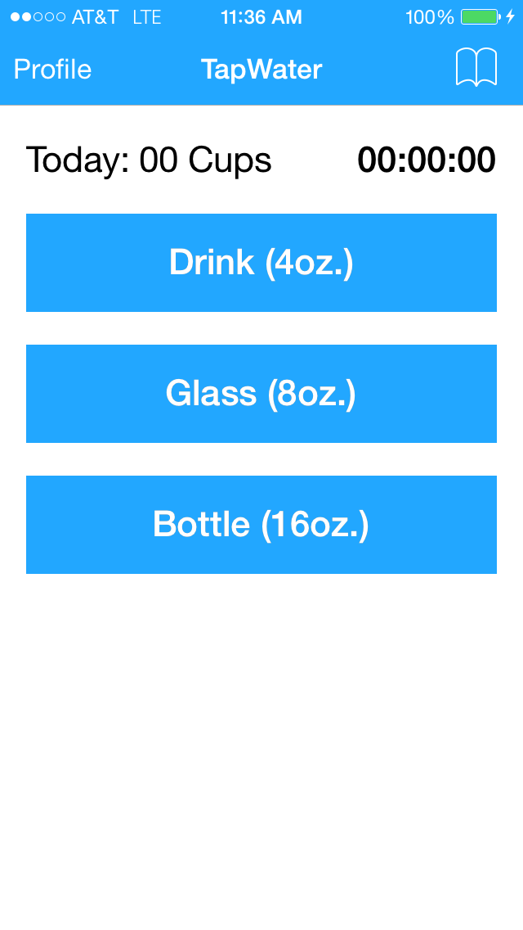
The main screen displays three predefined and common amounts of water a user can select. Tapping on “Profile” will bring the user to the profile screen with history, summary of drinks, amount of water needed to meet goal and next notification with drink amount recommendations.

3.1.4 Profile Screen
The profile screen shows the user name and summary of current drinks recorded. A “History” button will take the user to a more detailed view showing dates and amounts of each drink recorded. The user can also set customized notifications by tapping on “Notifications”. If user didn’t create an account, a button will be present for the user to register and push their local history to the server. Tapping the “TapWater” button will bring the user back to home screen.

3.1.5 Drink History Screen

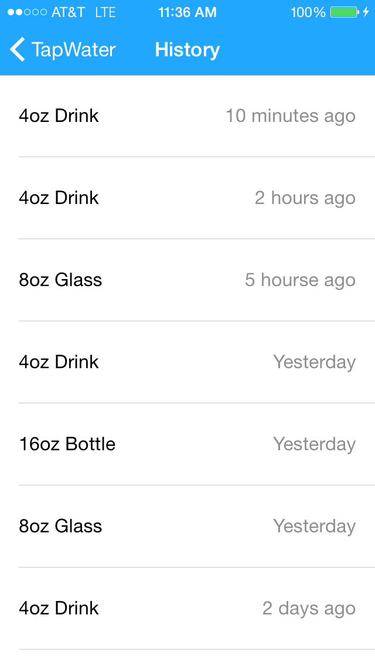
The history screen lists the user’s drink history in chronological order. Details include time elapsed since each drink based on user’s current time and how much the user drank. The user will also be able to use this screen to delete, duplicate or accidental drinks. Tapping on “TapWater” will bring you back to the home screen.

3.1.6 Drink Notification Schedule Screen
This screen allows users to schedule notifications to remind them to drink water. There are fields where the user can set a goal for the number and amount of drinks they want to reach for the day. The user will then select a beginning/end time from within the 24 hour day. An enable/disable notifications toggle will control notifications for the device.

Hardware Interfaces
TapWater is being developed and deployed as a mobile system for iOS and Android platforms. This includes mobile phones and tablets running supported versions of iOS (7+) and Android (4.0+). User accounts and drink history will be synchronized across each device hosted on a server through Heroku. The notification service is a locally run service and not handled by the server.
TapWater is only being developed for iOS 7+ and Android 4.0+ and updated periodically to add features, squash bugs and adhere to each company’s design guidelines. Network communication and hardware interface methods are provided by the iOS and Android platforms.

Software Interfaces
The TapWater system developed for Android operating systems will be using the Java development kit and the Android software development kit tools. TapWater for iOS will be developed in swift with the iOS software development kit.
TapWater has outgoing data consisting of user account creation, drinks and authentication requests to the server. Incoming data consists of drink history retrieval and authentication verification. The server is built in Ruby with Ruby on Rails web framework and features an system programming interface with the following capabilities: Creating and authenticating users, saving drinks associated with an authenticated user, and downloading an authenticated user’s drink history. TapWater’s drink reminder notifications are handled locally and communication with the server is not needed for that function.

Communications Interfaces
The TapWater system will be connected to a server hosted on Heroku built with in Ruby with the Ruby on Rails web framework. The server’s purpose is to store and retrieve information to and from the database and push them to each of the user’s devices. The Ruby on Rails framework contains an system programming interface for the three interactions the system will be making with the server and databases.

System Features
<This template illustrates organizing the functional requirements for the product by system features, the major services provided by the product. You may prefer to organize this section by use case, mode of operation, user class, object class, functional hierarchy, or combinations of these, whatever makes the most logical sense for your product.>

System Feature 1
<Don’t really say “System Feature 1.” State the feature name in just a few words.>
4.1.1 Description and Priority
<Provide a short description of the feature and indicate whether it is of High, Medium, or Low priority. You could also include specific priority component ratings, such as benefit, penalty, cost, and risk (each rated on a relative scale from a low of 1 to a high of 9).>
4.1.2 Stimulus/Response Sequences
<List the sequences of user actions and system responses that stimulate the behavior defined for this feature. These will correspond to the dialog elements associated with use cases.>
4.1.3 Functional Requirements
<Itemize the detailed functional requirements associated with this feature. These are the software capabilities that must be present in order for the user to carry out the services provided by the feature, or to execute the use case. Include how the product should respond to anticipated error conditions or invalid inputs. Requirements should be concise, complete, unambiguous, verifiable, and necessary. Use “TBD” as a placeholder to indicate when necessary information is not yet available.>

<Each requirement should be uniquely identified with a sequence number or a meaningful tag of some kind.>

REQ-1:
REQ-2:

System Feature 2 (and so on)

Other Nonfunctional Requirements

Performance Requirements
<If there are performance requirements for the product under various circumstances, state them here and explain their rationale, to help the developers understand the intent and make suitable design choices. Specify the timing relationships for real time systems. Make such requirements as specific as possible. You may need to state performance requirements for individual functional requirements or features.>

Safety Requirements
<Specify those requirements that are concerned with possible loss, damage, or harm that could result from the use of the product. Define any safeguards or actions that must be taken, as well as actions that must be prevented. Refer to any external policies or regulations that state safety issues that affect the product’s design or use. Define any safety certifications that must be satisfied.>

Security Requirements
<Specify any requirements regarding security or privacy issues surrounding use of the product or protection of the data used or created by the product. Define any user identity authentication requirements. Refer to any external policies or regulations containing security issues that affect the product. Define any security or privacy certifications that must be satisfied.>

Software Quality Attributes
<Specify any additional quality characteristics for the product that will be important to either the customers or the developers. Some to consider are: adaptability, availability, correctness, flexibility, interoperability, maintainability, portability, reliability, reusability, robustness, testability, and usability. Write these to be specific, quantitative, and verifiable when possible. At the least, clarify the relative preferences for various attributes, such as ease of use over ease of learning.>

Business Rules
<List any operating principles about the product, such as which individuals or roles can perform which functions under specific circumstances. These are not functional requirements in themselves, but they may imply certain functional requirements to enforce the rules.>

Other Requirements
<Define any other requirements not covered elsewhere in the SRS. This might include database requirements, internationalization requirements, legal requirements, reuse objectives for the project, and so on. Add any new sections that are pertinent to the project.>
Appendix A: Glossary
<Define all the terms necessary to properly interpret the SRS, including acronyms and abbreviations. You may wish to build a separate glossary that spans multiple projects or the entire organization, and just include terms specific to a single project in each SRS.>
Appendix B: Analysis Models
<Optionally, include any pertinent analysis models, such as data flow diagrams, class diagrams, state-transition diagrams, or entity-relationship diagrams.>
Appendix C: To Be Determined List
<Collect a numbered list of the TBD (to be determined) references that remain in the SRS so they can be tracked to closure.>

